# Practical 3

**Practical 3A: A RMI based application program to display current date and time. Code:**

# RMIInterfaceDate.java

import java.rmi.*;

public interface RMIInterfaceDate extends Remote { public String printDate() throws Exception;

}

# RMIServerDate.java

import java.rmi.*; import java.rmi.server.*; import java.util.*; import java.util.Date;

import java.text.SimpleDateFormat;

public class RMIServerDate extends UnicastRemoteObject implements RMIInterfaceDate

{

public RMIServerDate() throws Exception

{

System.out.println("Server is initialised");

}

public String printDate() throws Exception

{

Date d = new Date();

SimpleDateFormat myFormat = new SimpleDateFormat("dd-MM-yyyy hh:mm:ss"); String myDate = myFormat.format(d);

System.out.println("Server: "+myDate); return myDate;

}

public static void main (String[] args) throws Exception

{

System.out.println("RMIServerDate started. ");

RMIServerDate obj = new RMIServerDate(); Naming.bind("RMIServerDate",obj); System.out.println("Object registered. ");

}

}

# RMIClientDate.java

import java.rmi.*; import java.io.*;

public class RMIClientDate

{

public static void main (String[] args) throws Exception

{

System.out.println("RMIClientDate started. ");

RMIInterfaceDate server = (RMIInterfaceDate) Naming.lookup ("RMIServerDate"); String serverDate=server.printDate();

System.out.println("Server: " +serverDate);

}

}

# Output:

Open 3 Terminal & enter the following commands.

# 1st Terminal commands

* javac RMIInterfaceDate.java
* javac RMIServerDate.java
* javac RMIClientDate.java
* rmic RMIServerDate
* rmiregistry

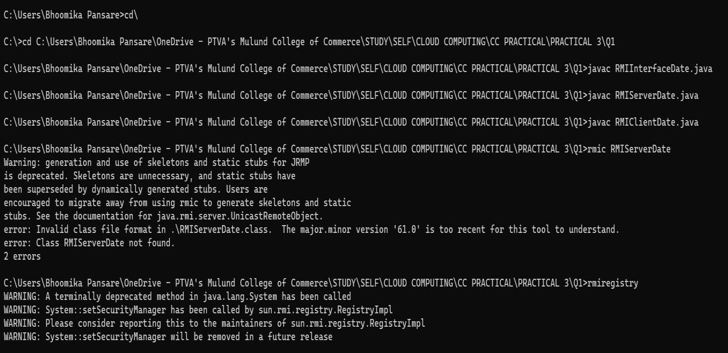

# 2nd Terminal commands

* javac RMIServerDate.java
* java RMIServerDate

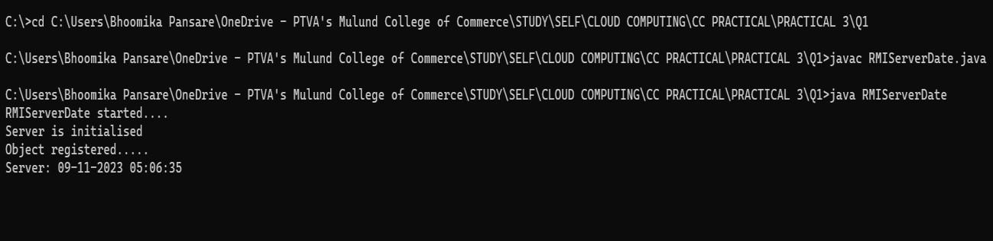

# 3rd Terminal Commands

* javac RMIClientDate.java
* java RMIClientDate

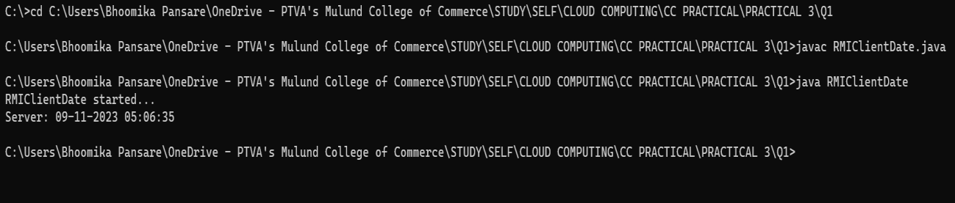

# Practical 3B: A RMI based application program that converts digits to words, e.g. 123 will be converted to one two three.

**Code:**

# InterConvert.java

import java.rmi.*;

public interface InterConvert extends Remote {

public String convertDigit(String no) throws Exception;

}

1. **ServerConvert.java** import java.rmi.*; import java.rmi.server.*;

public class ServerConvert extends UnicastRemoteObject implements InterConvert { public ServerConvert() throws Exception { }

public String convertDigit(String no) throws Exception { String str = "";

for(int i = 0; i < no.length(); i++) { int p = no.charAt(i); if( p == 48) { str += "zero ";

} if( p == 49) {

str += "one ";

} if( p == 50) {

str += "two ";

} if( p == 51) {

str += "three ";

} if( p == 52) {

str += "four ";

} if( p == 53) {

str += "five ";

} if( p == 54) {

str += "six ";

} if( p == 55) {

str += "seven ";

} if( p == 56) {

str += "eight ";

} if( p == 57) {

str += "nine ";

}

} return str;

}

public static void main(String args[]) throws Exception { ServerConvert s1 = new ServerConvert(); Naming.bind("Wrd",s1);

System.out.println("Object registered. ");

}

}

1. **ClientConvert.java** import java.rmi.*; import java.io.*;

public class ClientConvert {

public static void main(String args[]) throws Exception { InterConvert h1 = (InterConvert)Naming.lookup("Wrd");

BufferedReader br = new BufferedReader(new InputStreamReader(System.in)); System.out.println("Enter a number : \t");

String no = br.readLine();

String ans = h1.convertDigit(no);

System.out.println("The word representation of the entered digit is : " +ans);

}

}

# Output:

**1st Terminal**

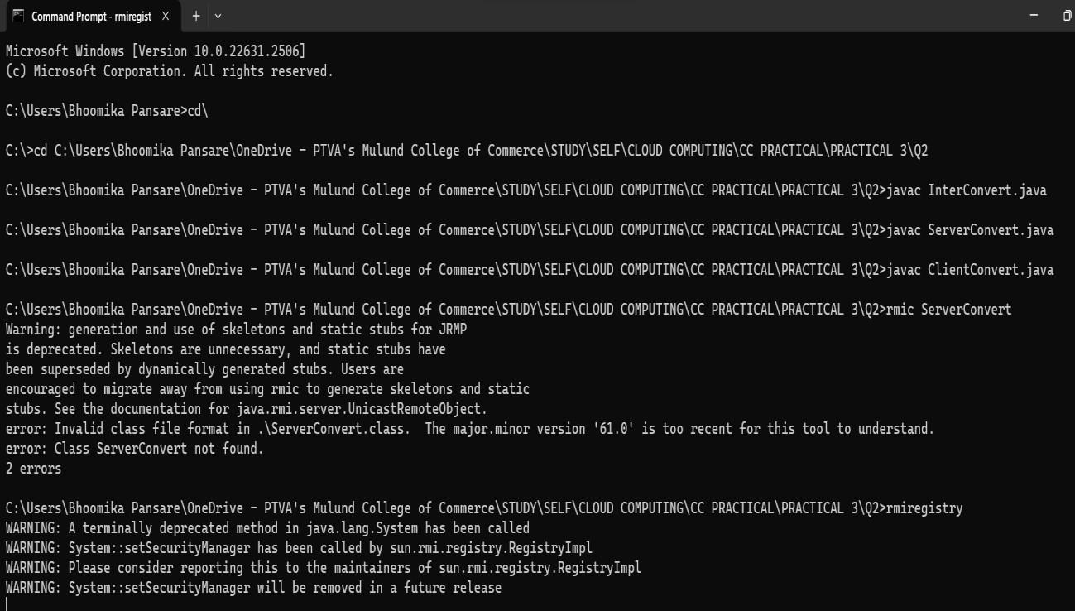

**2nd Terminal**

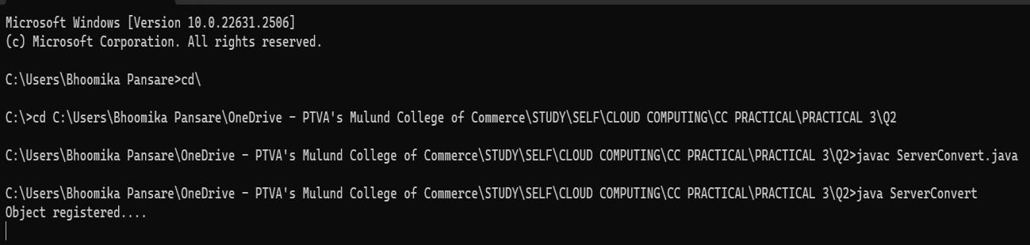

**3rd Terminal**

